**Purpose**

To establish a procedure on how to gross and process muscle biopsies for pathology laboratory personnel.

**Procedure**

The fresh muscle will be frozen by the IPOX/Muscle personnel. If specimen is received at UMHS, accession and send ASAP to NCRC.

If specimen is received after hours (after 9 pm during the week) when there are no IPOX/Muscle personnel at NCRC to properly freeze the muscle, page the neuropathology attending on call and notify. Place the specimen in the fridge (4°C), notify neuropathologist on muscle service, Muscle leading technologist (April Oler) and accessioner at UMHS. The specimen needs to be properly accessioned and sent to NCRC first thing the next morning. Under no circumstance leave the specimen at room temperature.

You may receive 3 containers/pieces –**scalpel open** **biopsies > 16 years old:**

1. Fresh to be frozen or already frozen tissue for histochemical analysis (Muscle lab).

2. Formalin fixed for paraffin embedding (Histology Lab).

3. A piece in glutaraldehyde **to place on hold for possible** electron microscopy (EM Lab).

You may receive 3 containers/pieces –**scalpel open biopsies, PEDIATRIC < 16 years old:**

1. Fresh tissue to be frozen or already frozen tissue for histochemical analysis (Muscle Lab)

2. Fresh tissue to flash freeze in liquid nitrogen or previously snap frozen for potential send out testing (e.g. metabolic/genetic testing) (Muscle lab).

3. A piece in glutaraldehyde **to place on hold for possible** electron microscopy (EM Lab).

You may receive 1 container from needle biopsies (**Not fine needle aspiration; this is larger than that; if FNA size call neuropathologist before proceeding**).

Send all the fresh specimen to the Muscle lab. They will freeze and take a small piece for EM. Do not put tissue in formalin, unless instructed by neuropathologist.

1. **Freezing Procedure for Histochemical Analysis (For Muscle Lab)**

* Confirm patient’s name, medical record number, DOB.
* Supplies are on the bench of the Muscle lab/DIF area NCRC-35-G434 and first drawer labeled “Freezing supplies”.
* Isopentane is on the top shelf of the 4°C refrigerator located directly behind the freezing area.
* Liquid nitrogen is under the bench.  
   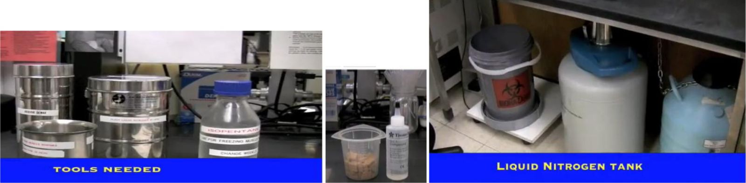
* Take tissue out. It may come in wet gauze. Transfer to a dry gauze and gently pad the tissue to remove extra moisture. Keep tissue away from cold air. Extra moisture and cold air can give freezing artifacts.  Dry with gauze the container and place the container in the cryostat to cool down. This will be used to store the frozen tissue later on.
* If the requisition does not state that a piece was sent for electron microscopy (EM) studies, take a small piece (similar in thickness to a match or a rounded toothpick) and placed into glutaraldehyde for EM. Glutaraldehyde is located on the top shelf of the 4°C fridge, behind the freezing counter. This step is often done by the person freezing the muscle for histochemistry, before starting the freezing procedure, only if enough tissue is available. Label the glutaraldehyde bottle with accession number, patient name, MRN, and DOB and place in the EM fridge in the NCRC gross room fridge and log on EM log sheet.
* Take isopentane from 4°C refrigerator and pour into metal beaker. Cool the isopentane down to -160°C by slowly lowering the metal beaker into the liquid nitrogen using the metal ring with handle. Liquid nitrogen will need to be poured into the dewar multiple times to get the isopentane down to temperature. The isopentane is down to temperature when the isopentane turns milky white and is firm on the bottom of the beaker.

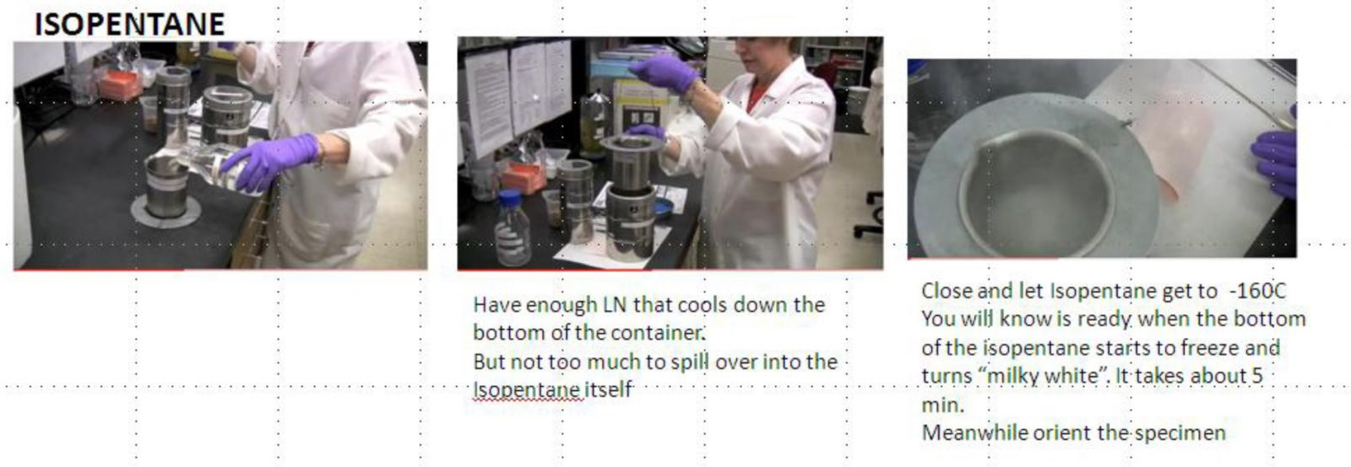

* While Isopentane cools down orient specimen in cross section   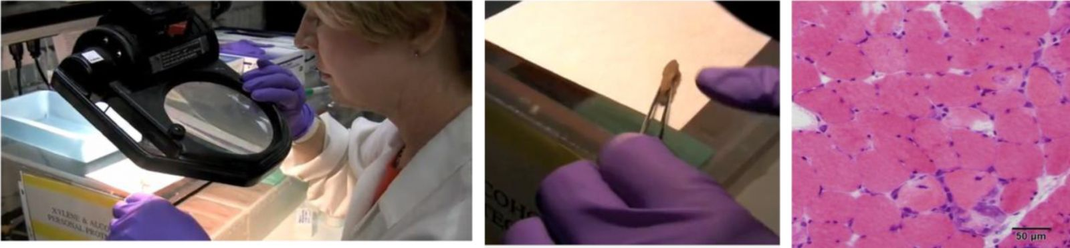

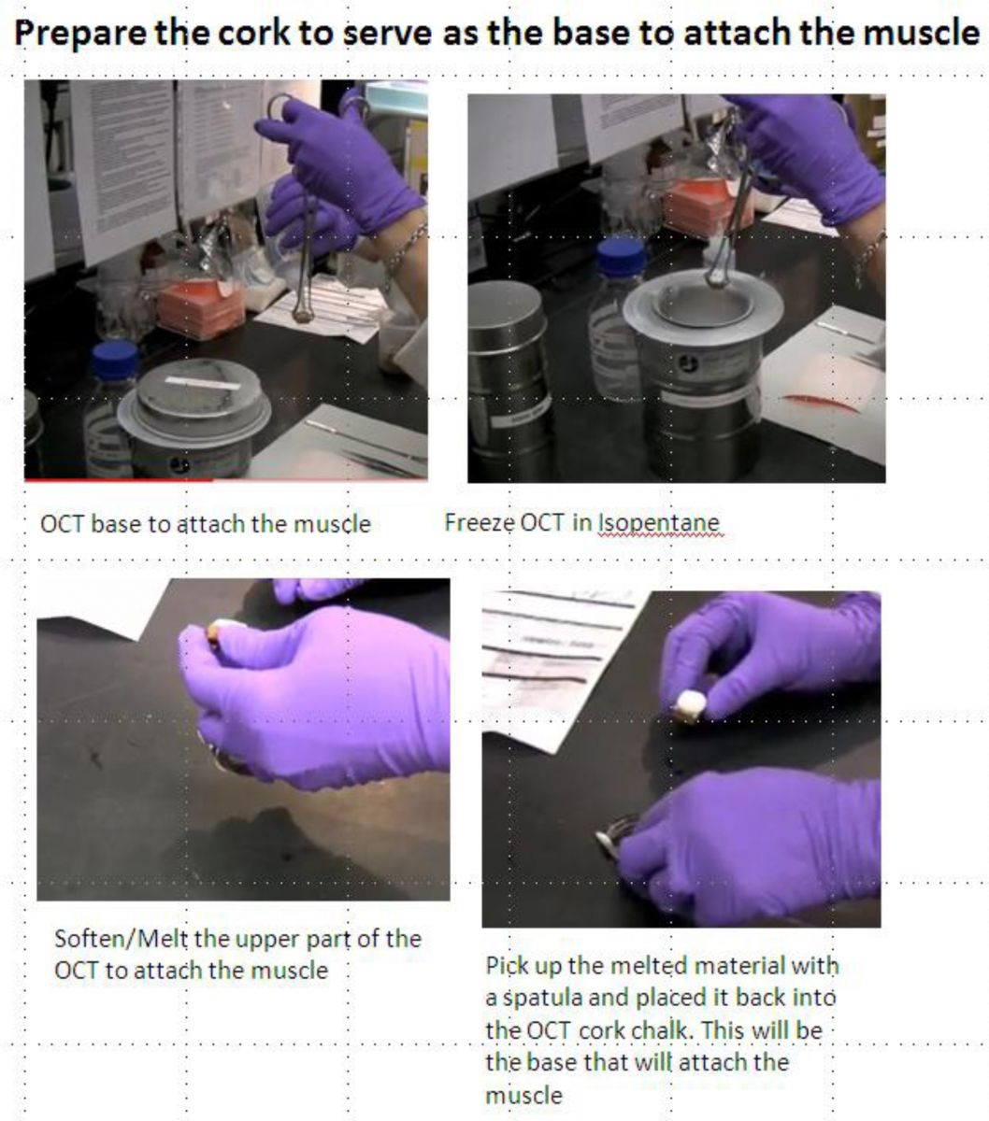

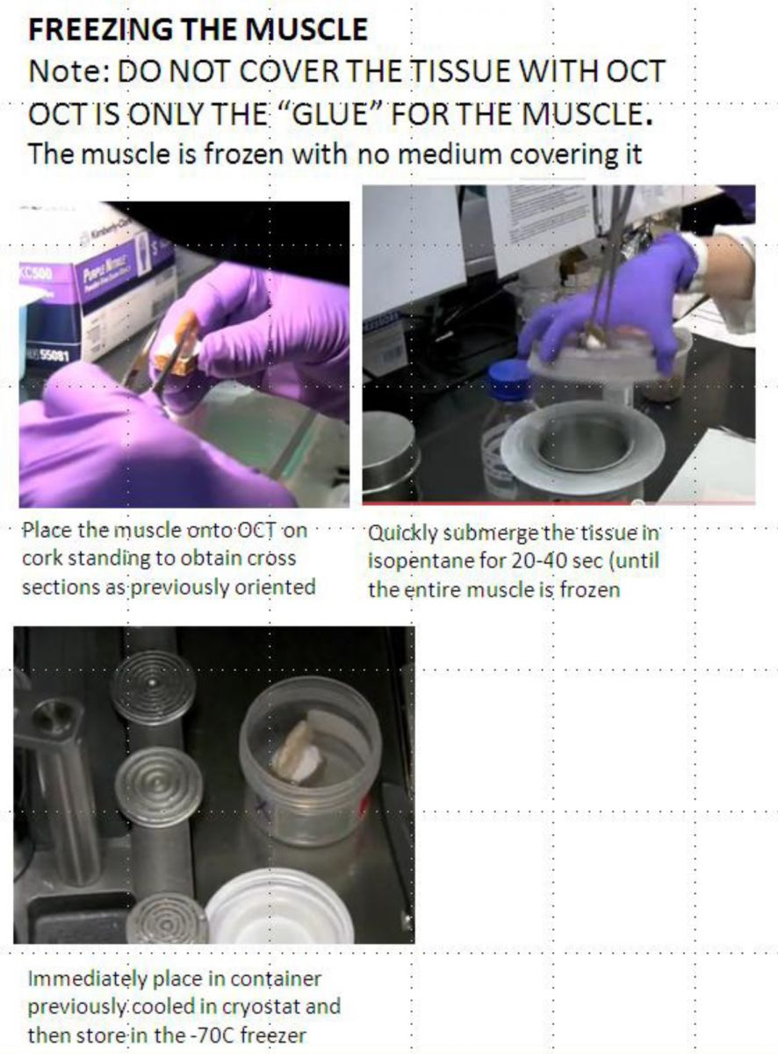

Clean instruments, return supplies to appropriate shelf and pour back left over isopentane in glass container and store at 4C for future use.  
Well done, you did it!

1. **For formalin fixed muscle (Submit to Histology)**

* Remove tissue from tongue depressor.
* Identify the striations in the muscle.
* With a scalpel, cut tissue equally into cross and longitudinal sections.
* Ink the sections you want embedded using green ink.
* Submit tissue into two separate green cassettes: 1 for cross sections and 1 for longitudinal sections. Note: You will always receive 2 cassettes for muscle biopsy cases. See photographs below.
* Most muscle biopsy cases contain a piece of frozen muscle, which is sent separately to the frozen muscle lab. In addition, the grosser will also receive a sample of muscle in glutaraldehyde (See appropriate sections for handling).

***Sections for Histology***

* Submit entire formalin fixed muscle sample for paraffin embedding in at least two green cassettes (separated into cross and longitudinal sections). (See representative pictures below in photographs for formalin fixed tissue)

***Sample Photographs for Formalin fixed tissue***

* 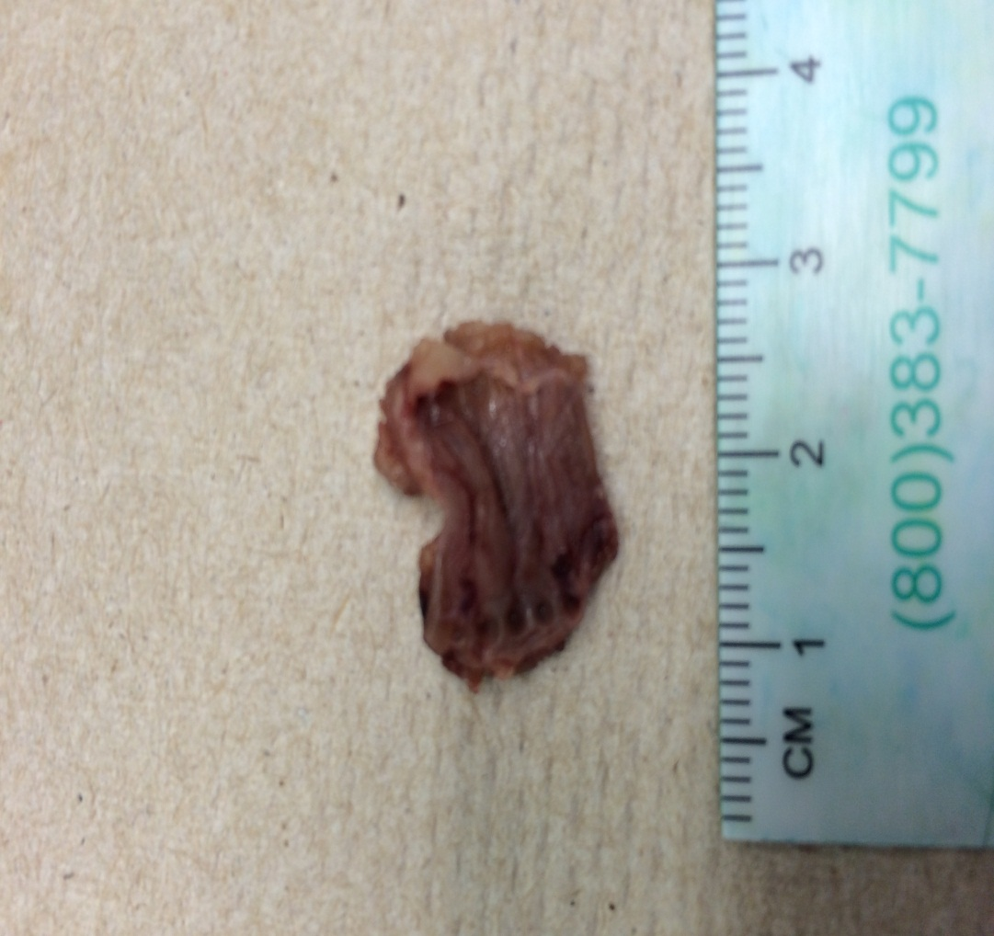

Orient specimen by striations (here running longitudinally from clamp marks (left) to fascia or fat (right). A magnifying lens can help with orientation.

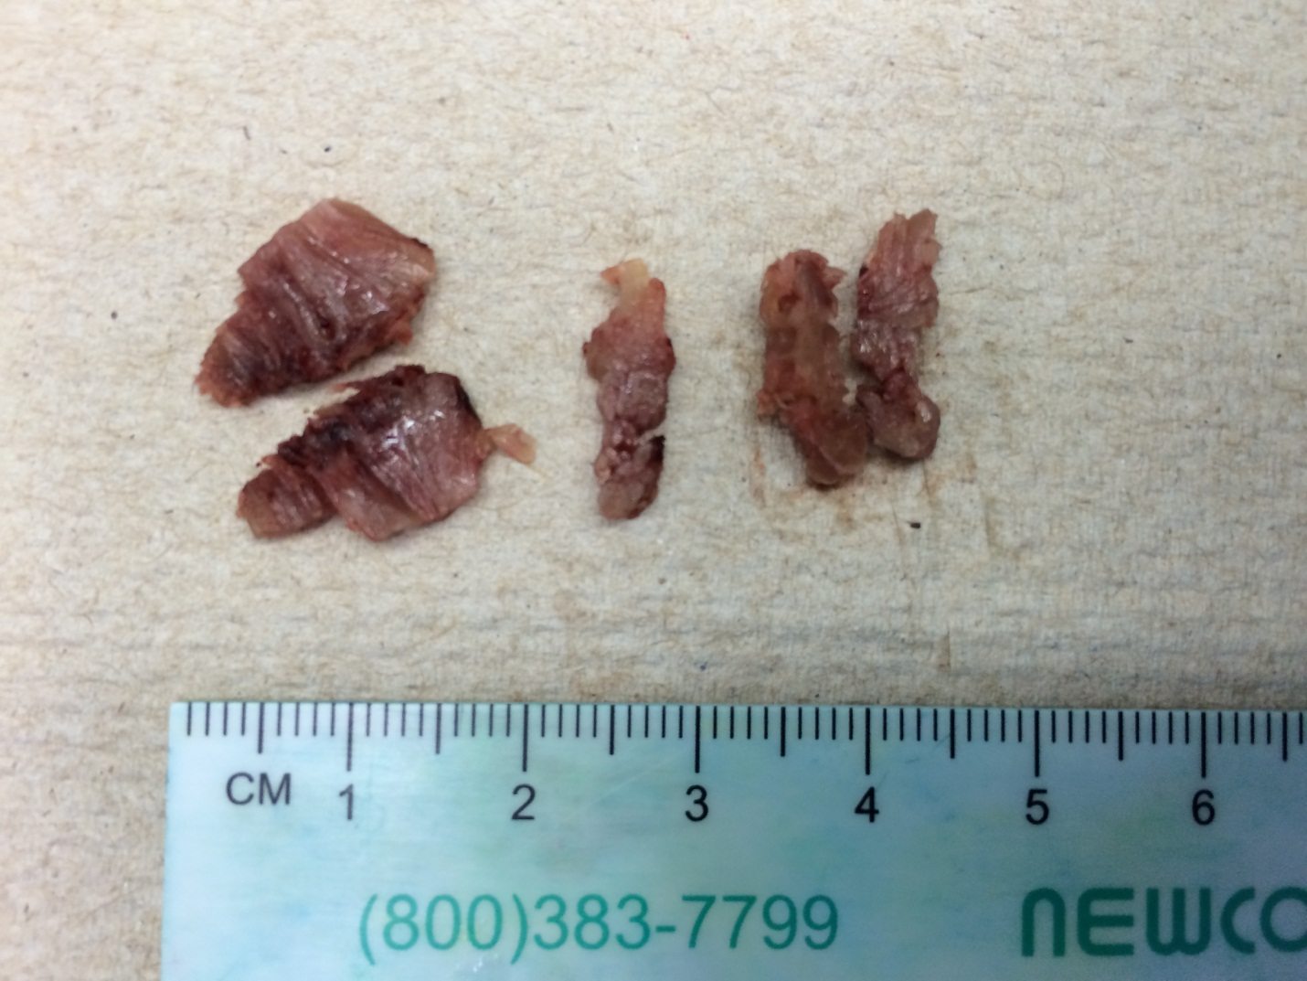

* Cut muscle into longitudinal (left 0 - 2cm) and cross (right 2.5-5 cm) sections.

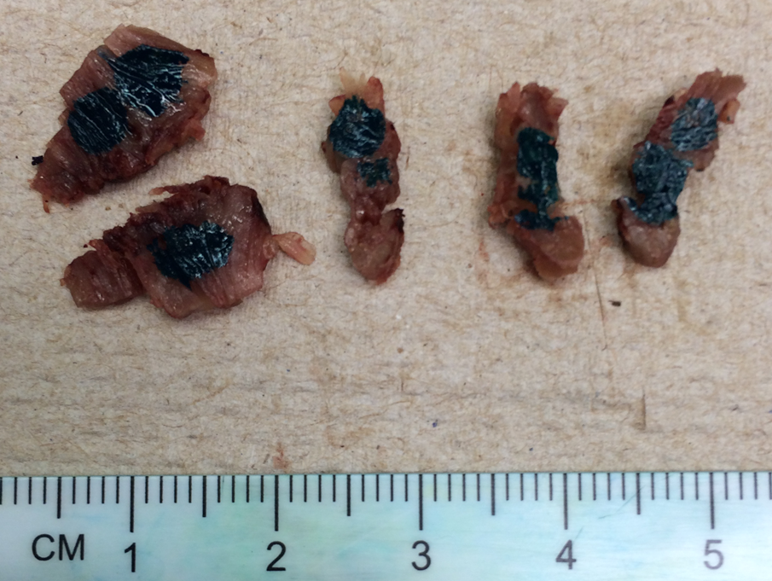

* Ink sections to be embedded down with green ink and green ink only.

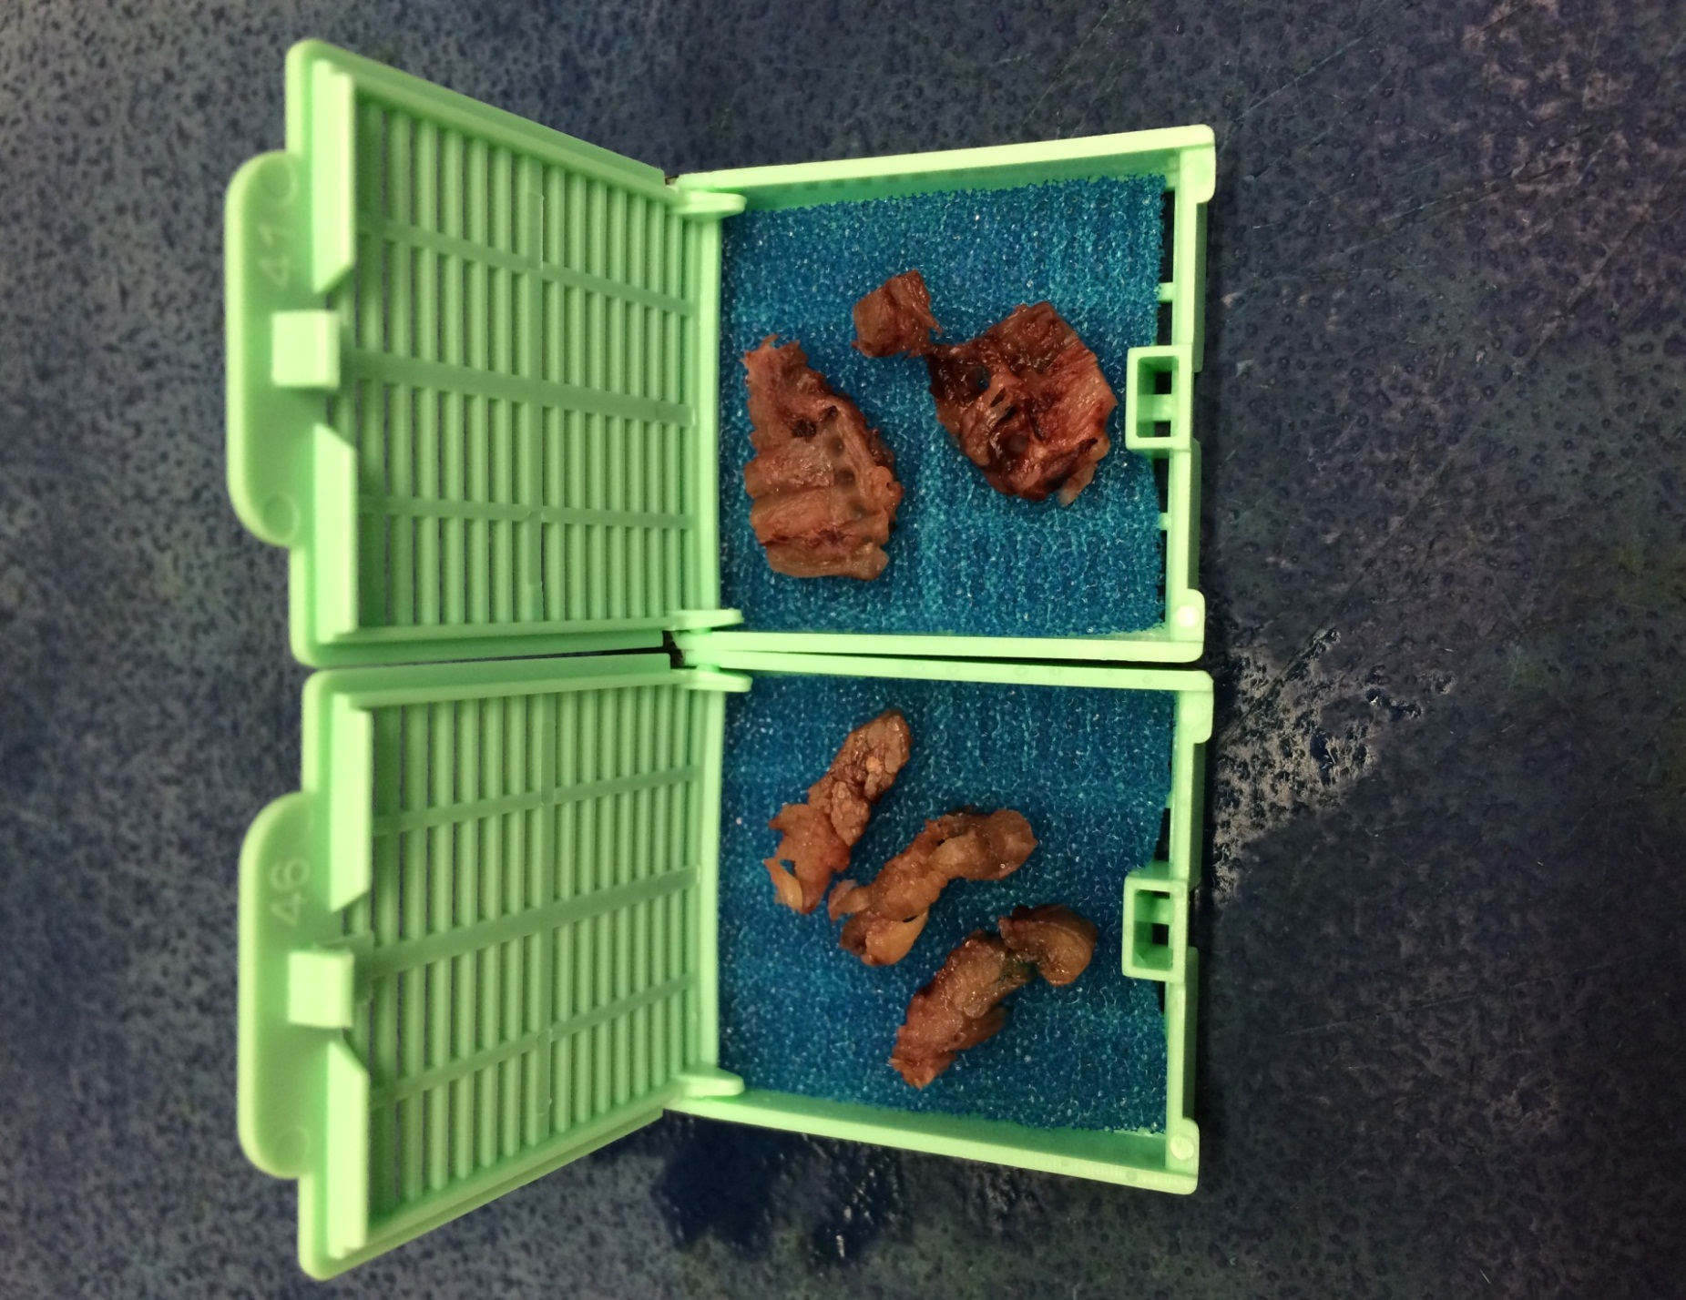

* Submitt cross sections in one cassette (right) and longitudinal sections (left) in the other cassette.

1. **For Possible Electron Microscopy (EM Lab)**

* A separate piece may come already in glutaraldehyde to place on hold for possible EM. The tissue sample may be pending in the room 2 fridge. After grossed, place the vial along with a copy of the requisition back in the room 2 fridge located under the large scale and log the sample in on the log sheet (also within the room 2 fridge). EM personnel will pick up the vial and bring to EM lab for further testing.
* ***Alternatively, Muscle Lab personnel may take a small piece from the fresh tissue and submit to EM Lab.***

**Note:** Regardless the case, make sure to include this in the dictation including the size of the specimen for EM. This will become a new part automatically in Soft.

*Sample Dictations*

“Left Quadriceps”,

1. Received in a small container filled with formalin is a 1.5 x 1.0 x 0.8 cm skeletal muscle segment. Sectioned for cross and longitudinal sections. Cut surfaces inked green. Cassette Summary: A1. Cross sections (4ns) A2. Longitudinal sections (2ns)
2. Frozen muscle will be dictated and sectioned by the frozen muscle lab. (Received fresh or previously frozen is a piece of muscle 1x1x1 cm submitted for histochemistry)
3. Received in a small vial filled with glutaraldehyde is a 1.5 x 1.0 x 0.8 cm skeletal muscle segment. (or a piece from part B is fixed in glutaraldehyde and placed on hold for possible EM studies).
4. Received previously frozen, or received fresh for metabolic/genetic testing is a piece of muscle 1 x 1 x 1 cm snap frozen in Liquid Nitrogen and placed on hold in Muscle lab for possible future studies.

Example of how EM should be entered in gross dictation when a piece is taken in the muscle lab:

"Left VL"

A. Received fresh tissue measuring 0.9 x 0.9 x 0.5 cm for muscle histochemistry.

B. A portion was placed in glutaraldehyde for possible EM studies, measuring 0.6 x 0.2 x 0.1 cm. IPOX

Note: Sometimes the muscle lab will receive the frozen tissue prior to other tests. In these instances, they will write the dimensions of the frozen tissue on the requisition. Please dictate the dimensions of the tissue and stat “sectioned for histochemistry (See highlighted text above)”.

1. **Metabolic/Genetic Future Send out (Muscle Lab)**

* The requisition has to specifically indicate that tissue is also needed for future send out. Often this piece comes in a different container either fresh or previously flash frozen in Liquid Nitrogen if received from Dr. Little.
* If fresh, take the piece of muscle, placed in a cassette/cryotube (Label container with identifiers) and directly frozen in Liquid nitrogen, then store at -70 C. This will be used for potential send out tests for metabolic/genetic testing